 

**INDIVIDUAL ASSIGNMENT**

**LANKA**

**COMP40004**

**WEB DEVELOPMENT AND OPERATING SYSTEMS-1 COMK2461**

**HAND OUT DATE: 15th July 2024**

HAND IN DATE: ASSIGNMENT2: 13th September 2024

**WEIGHTAGE: ASSIGNMENT 2: 30%**

**Name – Muthusaamypillai Thavapragasam Sarathchandran Mallesh**

**Student Number – CB015988**

**Batch Code – COMK2461**

# Contents

**1.) Acknowledgement**

**2.) Introduction**

**3.) Wireframes**

**4.) Challenges faced**

**5.) What I have learned**

**6.) Reference**

# Acknowledgement

I would like to express my gratitude to my lecturer Mr. Pradeep Pallegama to helping me to get a good understanding, making web development lectures interesting and to guiding me through the WDOS 1 module.

I would also thank and my fellow batchmates for helping me and clearing my doubts when I was not able to get few things done properly and for making all the lectures fun and motivational by encouraging me.

Thank you all for being there for me supporting me till now!!

# Introduction

This report outlines the process and key elements involved in me developing a hospital website, named "Lifeline Hospital." The website includes multiple pages such as Home, About Us, Services, Doctors, Consulting Reservation, and Pharmacy. The project follows the requirements specified in the assignment, with a focus on creating a website using pure HTML and CSS.

# Wireframes

Home page

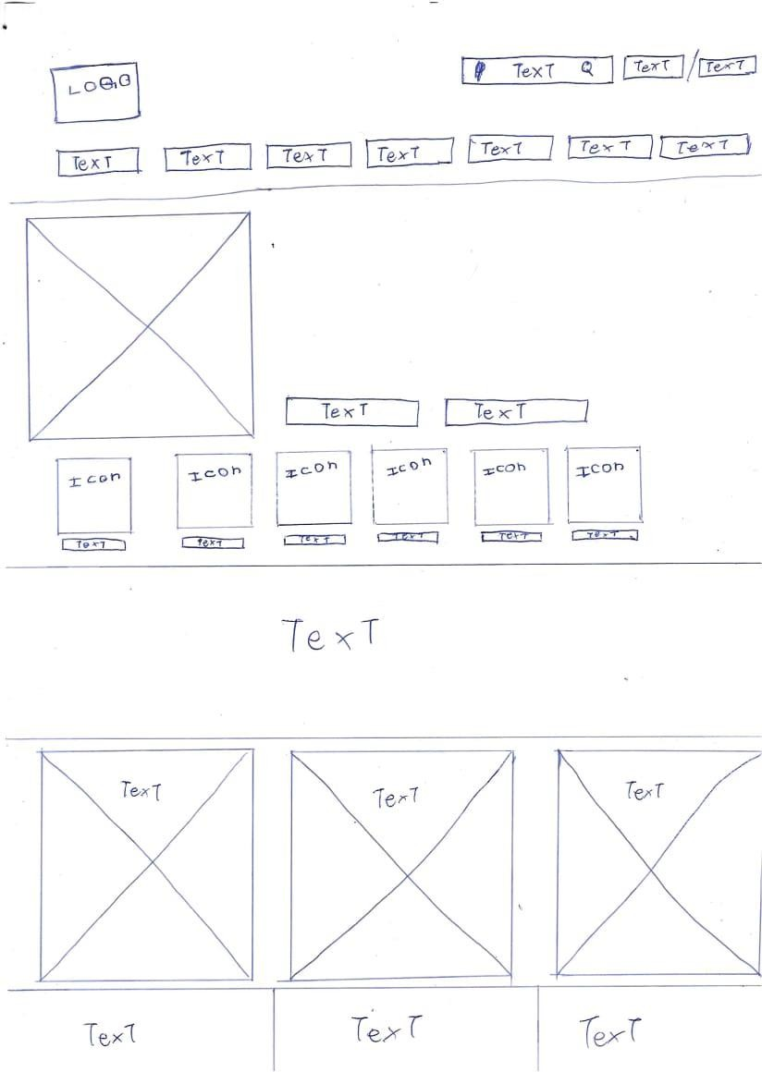

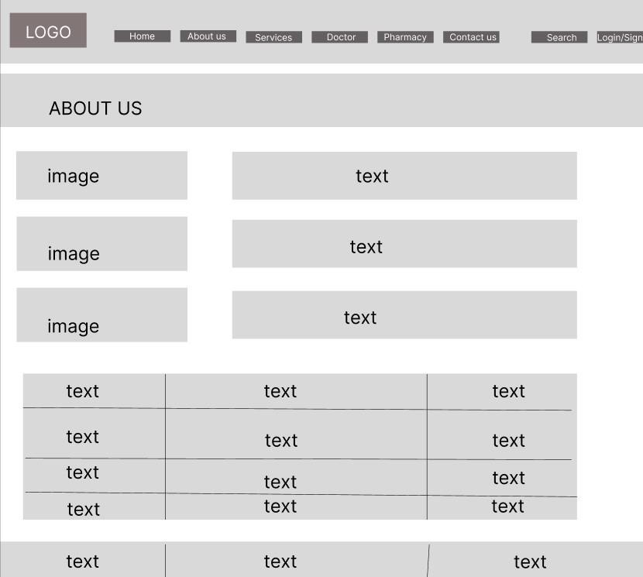

**About Us**

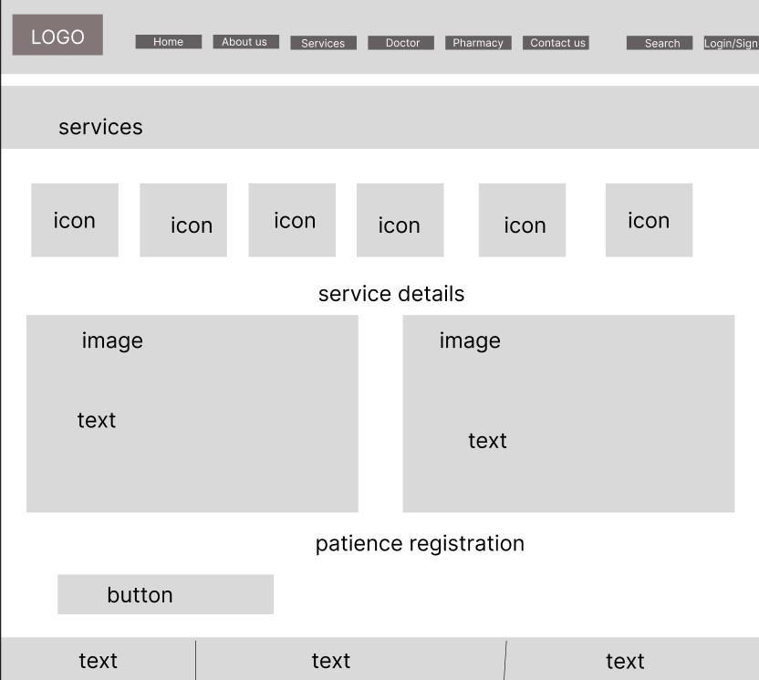**Services**

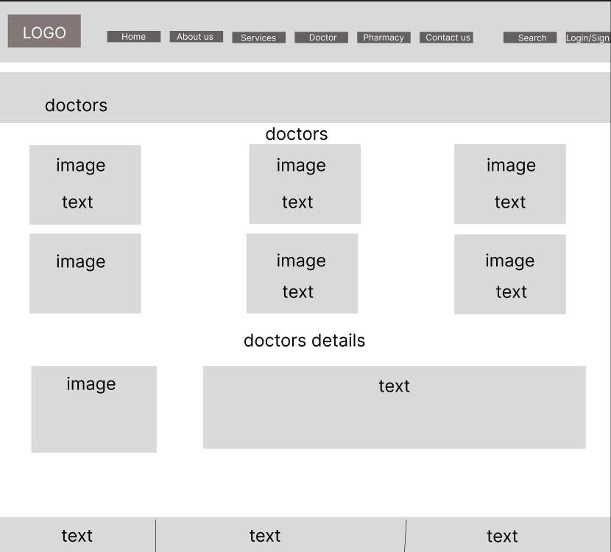**Doctors**

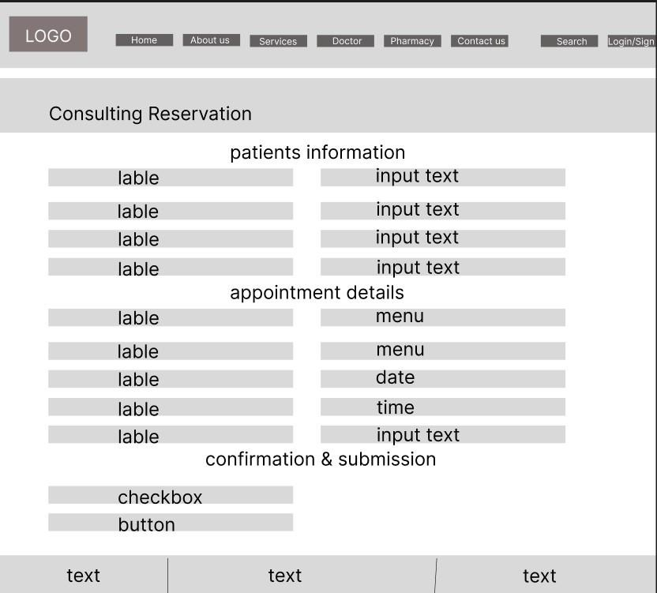**Consulting reservations**

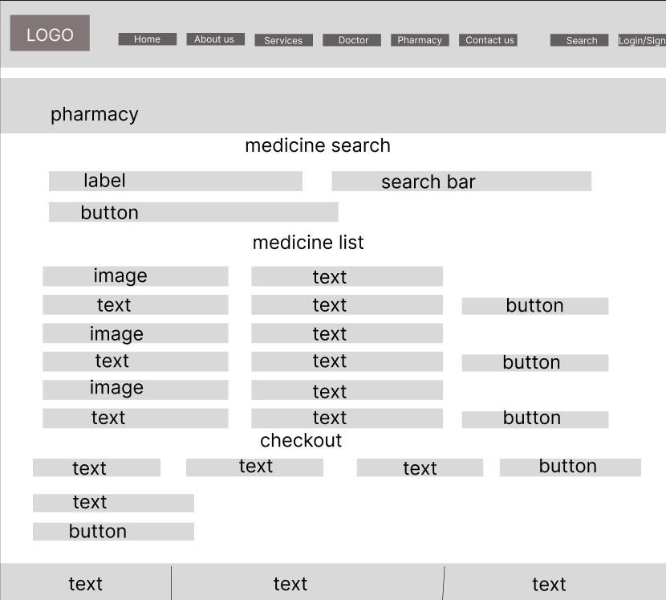**Pharmacy**

# Challenges Faced

During the development of the website, I faced several challenges, which provided valuable learning experiences

1. **The first problem I faced was with the logo as I was not able to resize the logo and had a background problem and then I had to change the**

code from <section></section> to <figure></figure> which helped me resize the logo through CSS and add the logo in the proper place.

 <header>

        <figure>

            <img src="C:\Users\USER\Desktop\WDOS Assignment\pictures\logo final.png" alt="Lifeline Hospital Logo">

        </figure>



 <section>

            <img src="C:\Users\USER\Desktop\WDOS Assignment\pictures\logo final.png" alt="Lifeline Hospital Logo">

        </section>

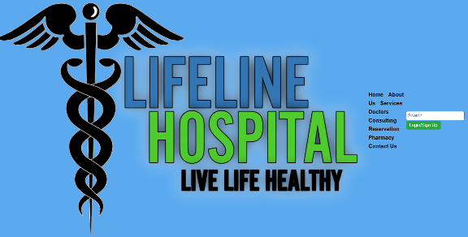

1. **The second problem that I faced was with the CSS as I could not find the proper way of make my CSS code responsive to mobile view and to few figures that I added in the HTML.**

# What I have learned

Throughout the assignment I gained a deeper level of understanding about several web development concepts and the functions of some new commands which were helpful for me to make my website the way I wanted it to be previewed by others:

* **Semantic HTML: The importance of using semantic tags for better accessibility and SEO.**
* **Responsive Design: How to create layouts that adapt to different screen sizes and devices.**
* **CSS Techniques: Learning how to style web pages effectively using**

CSS, including the use of Flexbox and Grid for layout,

and how to create responsive images a text.

# Reference

• **Asiri Hospital Website:**

* Asiri Health. (n.d.). *Asiri Hospital Website*. Available at: <https://asirihealth.com/>

• **Suwasewana Hospital Website:**

* Suwasewana Hospital. (n.d.). *Suwasewana Hospital Website*. Available at: <https://suwasevana.lk/>

• **LearnCode.academy YouTube Channel:**

* LearnCode.academy. (n.d.). *LearnCode.academy [YouTube Channel]*. Available at: <https://www.youtube.com/@learncodeacademy>

• **Flexbox Froggy:**

* Codepip. (n.d.). *Flexbox Froggy*. Available at: <https://flexboxfroggy.com/>

• **Grid Garden:**

* Codepip. (n.d.). *Grid Garden*. Available at: <https://cssgridgarden.com/>